
Patuakhali Science and Technology University
Dumki, Patuakhali
CCE 322: Computer Peripheral and Interfacing Sessional
Final Report

Project Title: "A Smart Local Health Monitoring and Assistance System with Wi-Fi Connected Flutter Mobile Application"
Submission Date: 18, june 2026
Submitted from, | Submitted to,
Jannatul akiba  ID: 2102076,  Basudha shome  ID: 202035,  Semester: 6 (Level-3, Semester-2) | - Sarna Majumder  Associate Professor,  Department of Computer and Communication Engineering,  Patuakhali Science and Technology University.  - Prof. Dr. Md Samsuzzaman  Professor,  Department of Computer and Communication Engineering,  Patuakhali Science and Technology University.

Contents
1. Abstract | 3
2. Problem Statement | 3
3. Objective | 3
4. Updated System Features | 3
4.1. Device-side Features | 3
4.2. Mobile Application Features | 3
5. System Architecture | 4
6. Components Required | 4
7. Notes on the important hardware design | 5
8. Pin Diagram and Wiring Guide | 5
9. Main Pin Mapping Table | 6
10. Sensor-specific Wiring Instructions | 7
11. Sustenance and Health of the Environment | 8
12. Working Methodology | 9
13. Functional Modules | 9
14. Testing Plan | 9
15. Limitations | 9
16. Future Scope | 9
17. Conclusion | 9
18. Cost analysis | 10

1. Abstract
MediLink Pi is a smart local healthcare monitoring and assistance system based on the Raspberry Pi 3 Model B and a mobile application that is developed utilizing the Flutter framework which is based on the Wi-Fi connection.
It is a device that measures heart rate, blood oxygen saturation level, body temperature, ECG signal and also skin response data, and analyzes the data to show a simplified status as Normal, Warning or Critical. The system also reminds medicine, stores local history, and enables real-time viewing with the mobile application which is connected on the same local network.
The present report is an extended version of the original concept, which also includes an ECG sensor (AD8232) as well as a comprehensive Raspberry Pi 3 oriented pin and wiring guide.
2. Problem Statement
A large number of student health monitoring projects include only a few raw sensor readings and do not provide a comprehensive assistance process for a user/caregiver. A more robust system would need to track a variety of health parameters, issue warnings, store the information, facilitate emergency response and enable easy inspection using a mobile device, without relying on a complete cloudbased system. MediLink Pi fills this void by delivering health sensing, local intelligence, alerting, recording, and connectivity via a same-Wi-Fi mobile application in a practical, low-cost prototype.
3. Objective
- Use MAX30102 to monitor heart rate and SpO2. Take body temperature (MLX90614).
- Record the basic ECG signal from the sensor (AD8232). Read the skin response of stress, with a GSR sensor.
- Detect Normal, Warning and Critical states of a patient using threshold rules.
- Save data on the device for later viewing in the mobile application.
- Share real-time data with a Flutter app on the same WiFi network via local APIs.
4. Updated System Features
4.1. Device-side Features
- Real-time monitoring of heart rate and SpO2 with the MAX30102. Monitoring body temperature with MLX90614.
- Acquiring ECG waveforms by using AD8232 and ADS1115 ADC. The skin response monitoring system using the ADS1115 ADC is developed and implemented by GSR.
- Reminder about medicine with local scheduler and notification prompt.
4.2. Mobile Application Features
- Live dashboard for heart rate, SpO2, temperature, ECG status.
- Current patient State display and time of last update. Previous records (Health history page). Reminders setup and schedule view.
- Raspberry Pi Settings page to set IP address and threshold. Real-time communication via API (general requests).
The increasing frequency of natural disasters and home-related accidents demands robust and intelligent safety systems. This project uses sensors and microcontrollers to detect various emergencies and immediately inform the user while activating preventive measures.
5. System Architecture
Layer | Main Components | Role
Interface Layer | ADS1115 ADC, GPIO, I²C bus, 1-Wire bus | Connect analog and digital devices to the Pi
Processing Layer | All of the above would be available | Process data, classify, and store data
Service Layer | API + WebSocket | Show real-time and archived data to the app
Application Layer | Flutter dashboard, history page, alerts, settings | Interactions between the user and the caregiver

6. Component Required:
- Raspberry Pi 3 Model B: The main controller and local server that manages the entire system.
- MAX30102 Sensor: An essential sensor used to collect heart rate and $SpO_2$ (blood oxygen) data.
- MLX90614 Sensor: An essential non-contact sensor used to measure body temperature.
- AD8232 Sensor (Optional): An optional sensor capable of detecting basic ECG waveforms.
- GSR Sensor (Optional): A Galvanic Skin Response sensor used to detect skin reaction and stress levels.

- ADS1115 ADC Converter: A signal converter essential for converting analog signals (from the AD8232 or GSR) into digital data for the Raspberry Pi.
- Buzzer (Future Integration): A component used for generating audio alerts via GPIO output.
- RGB LED / 3 LEDs (Future Integration): Visual indicators used to display different alert states via GPIO output.

7. Notes on the important hardware design
- Raspberry Pi 3 GPIO operates on 3.3V. Never use 5V on GPIO pins.
- Typically analog outputs are provided by AD8232. The Raspberry Pi 3 does not have any analog input; an ADS1115 ADC is needed.
- All modules connected should be grounded together.
- Each I²C device can share SDA and SCL with each other, including the MAX30102, and the MLX90614 and ADS1115.
- If you want to minimize the complexity of your final prototype, go with one main body temperature sensor: MLX90614.
8. Pin Diagram and Wiring Guide
The following diagram and tables are just for Raspberry Pi 3 Model B for illustrative purposes. The choice of this mapping is to ensure that the I²C devices remain on the default I²C bus, the MLX90614 is connected to the common 1-Wire line and the buzzer,
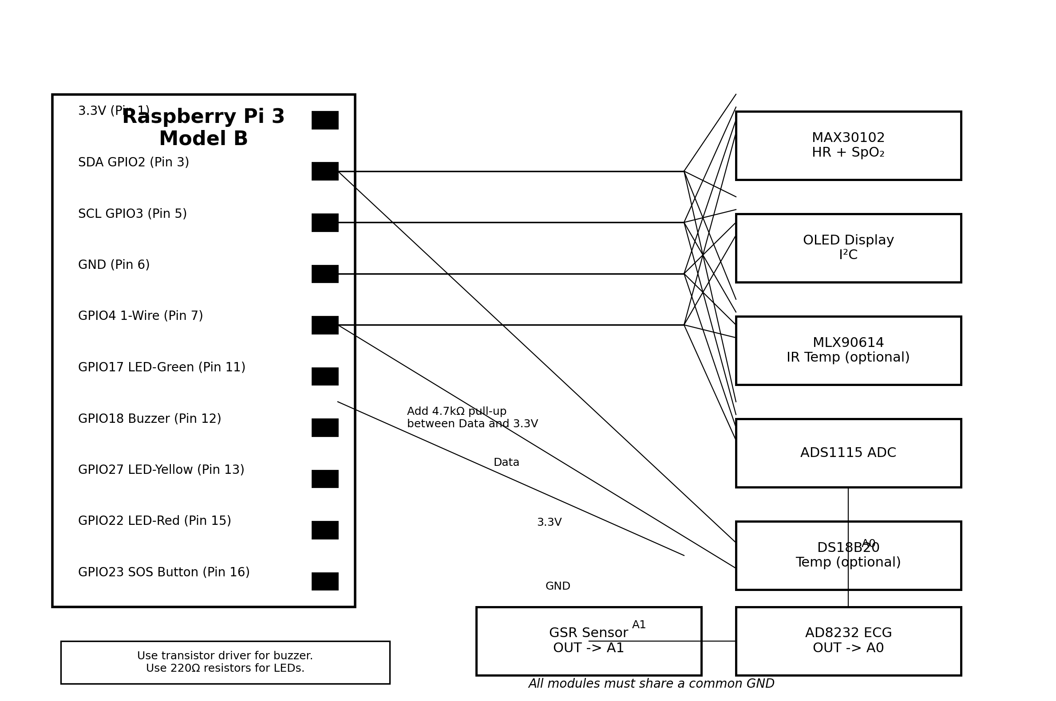
Figure 1. Proposed wiring overview for MediLink Pi on Raspberry Pi 3.
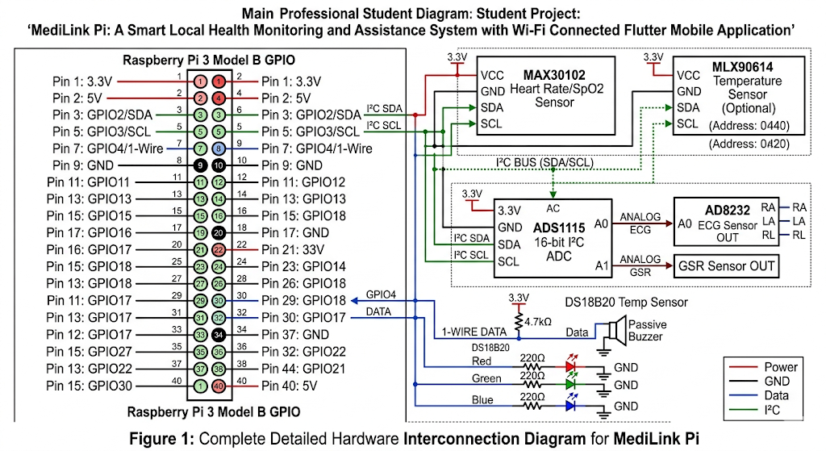
Fig2:Pin diagram after full setup MediLink Pi on Raspberry Pi 3.
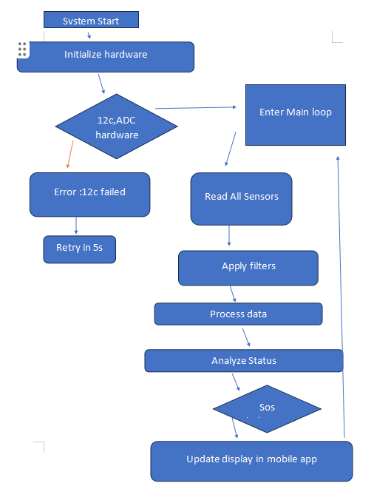
Fig 3: flowchart for the required project.
- Main Pin Mapping Table

Module / Signal | Raspberry Pi Pin | GPIO/Bus | Connection Detail | Remarks
MAX30102 VCC | Pin 1 | 3.3V | Power | Use 3.3V
MAX30102 GND | Pin 6 | GND | Ground | Common ground
MAX30102 SDA | Pin 3 | GPIO2/SDA | I²C data | Shared I²C bus
MAX30102 SCL | Pin 5 | GPIO3/SCL | I²C clock | Shared I²C bus
MLX90614 SDA (optional) | Pin 3 | GPIO2/SDA | I²C data | Optional temperature sensor
MLX90614 SCL (optional) | Pin 5 | GPIO3/SCL | I²C clock | Optional temperature sensor
AD8232 OUT | ADS1115 A0 | ADC input | Analog ECG signal | Do not connect direct to Pi GPIO
GSR OUT | ADS1115 A1 | ADC input | Analog skin response | Do not connect direct to Pi GPIO
ADS1115 VDD | Pin 1 | 3.3V | Power | Shared I²C supply
ADS1115 GND | Pin 9 or 6 | GND | Ground | Common ground
ADS1115 SDA | Pin 3 | GPIO2/SDA | I²C data | Shared bus
ADS1115 SCL | Pin 5 | GPIO3/SCL | I²C clock | Shared bus

10. Sensor-specific Wiring Instructions
A. MAX30102
Connect VCC to 3.3V and GND to ground. Connect SDA to GPIO2 (physical pin 3) and SCL to GPIO3 (physical pin 5). Connect the sensor to the common I²C bus between OLED, ADS1115 and optionally the MLX90614.
B. MLX90614
In case the device used is MLX90614, then it should be connected to the shared I²C bus. Use 3.3V, GND, SDA to GPIO2, and SCL to GPIO3. To prevent conflicts with other devices, verify the I²C address.
C. ADS1115 + AD8232 ECG
Connect ADS1115 to the Pi with 3.3V, GND, SDA and SCL. Connect VCC of AD8232 to 3.3V and GND to common ground. Connect AD8232 analog output pin to ADS1115 A0. Connect LO+ and LO- (for lead-off detection) if required by the selected AD8232 board; otherwise they can be unused in the basic prototype. Use various ECG electrode connections (RA, LA, and RL).
D. ADS1115 + GSR Sensor
Ensure the GSR module is powered by a safe voltage as per the module board and for Pi-side ADC input power the signal from 0-3.3V. Connect the analog signal output to ADS1115 A1. Run on the same ground as Raspberry Pi and ADS1115.
E. Buzzer, LEDs, and SOS(recommended for future integration)
Use a 220Ω resistor to connect each LED to its respective GPIO output and ground. Connect the buzzer control line to GPIO18. If the buzzer current is high, use a transistor driver. Attach the SOS button to GPIO23 and GND and set up the internal pull-up resistor in software.
11. Sustenance and Health of the Environment
- Install Raspberry Pi OS (Raspbian) and make both the Pi and Android phone connect to the same WiFi network.
- Enable the use of I²C and 1-Wire from configuration tools on Raspberry Pi.
- Install Python packages that are used for FastAPI or Flask, sensor libraries, handling of SQLite and communication via WebSocket.
- Develop Python modules for the different sensors: MAX30102, temperature sensor, ADS1115 ECG reader, and ADS1115 GSR reader.
- Design a medicine reminder scheduler and GPIO interrupt/polling routine for the SOS button events.
- Make endpoints available (such as /live, /history, /status, /sos, /settings).
- Design the pages for dashboard, history, alerts, reminders, and settings in Flutter.
- Save local IP address of Raspberry Pi in the app for the phone to connect to the Raspberry Pi within the same wifi network.
12. Working Methodology
The health-related values are being captured by sensors. In this step, Raspberry Pi can directly read digital sensors and analog sensors using ADS1115. If needed, the system filters noise and compares values to ranges of thresholds. The current state is determined as Normal, Warning or Critical by the rule engine. If a risk condition is identified, both buzzer and LED warnings will be triggered and mobile app will be updated. All readings have date and time. The Flutter app gets both real-time and historical data from the same Wi-Fi connection.
13. Functional Modules
- Vital Sign Monitoring Module: Collects heart rate, SpO2 temperature, ECG summary and GSR values. To classify condition using threshold rules.
- Alert Module: Buzzer and RGB LEDs control.(future work)
- Reminder Module: Medicine reminders on Pi and App.
- Emergency Module: Emergency events processing and Emergency state highlighting.
- Communication Module: Communicates data via API and WebSocket.
- Mobile Dashboard Module: Shows current values, history and settings.
14. Testing Plan
- Verify each sensor individually and get a stable reading from the sensor.
- ADC test: confirm that the values of AD8232 and GSR are received on A0 and A1 of the ADS1115.
- Alert test: check buzzer/LED response to abnormal threesholds. (future work)
- Verify live data update from Pi to Flutter app using Wi-Fi communication test.
- History test check if readings are saved and loaded properly.
The following are some of the benefits that the new system provides: Low cost and can be implemented practically for an academic prototype. Integrates embedded system, health sensing, networking and mobile application development. Supports direct patient monitoring and care giver friendly remote monitoring within the local network. The project is more enrich than a simple sensor display system with the introduction of ECG and GSR. Adds an external ADC for analog sensors and uses Raspberry Pi 3 successfully.
15. Limitations
This is a student prototype and cannot be shown as a medically certified diagnosis device. The quality of the sensor and the position of the sensor and other motion artifacts can interfere with sensor readings. ECG and GSR data for this version should be considered as basic monitoring data for demonstration and learning purposes only.
16. Future Scope
Cloud synchronization for caregiver access out of local network. Export to PDF for doctor review. Voice interaction and voice alerts. Additional modules like fall detection, blood pressure support, or camera integration. Machine learning based risk trend analysis from stored history.
System Component Analysis
Architectural Component Comparison
The following matrix provides a comprehensive technical breakdown of the hardware modules, sensors, integrated circuits, and software interfaces utilized in the system compared against standard implementations. This evaluation highlights the primary functionality, interconnectivity mechanisms, and key innovation vectors.
Component / Module | Primary Function(s) | Interface Method | Key Features & Innovations
Raspberry Pi 3 Model B | Central processing, data storage, server hosting | GPIO, I²C, 1-Wire, Wi-Fi | Low-cost embedded computer with wireless connectivity and multitasking capabilities.
MAX30102 | Heart rate and SpO₂ monitoring | I²C | Integrated pulse oximetry and heart-rate sensor with low power consumption.
MLX90614 | Non-contact temperature measurement | I²C | Infrared temperature sensing without physical contact.
ADS1115 | Analog-to-Digital Conversion | I²C | 16-bit high-precision ADC for interfacing analog sensors with Raspberry Pi.
AD8232 | ECG signal acquisition | Analog via ADS1115 | Low-power ECG front-end for monitoring cardiac electrical activity.

17. Conclusion
MediLink Pi is an academic-ready and technically complete intermediate-level smart healthcare assistant project, suitable for submission. Raspberry Pi 3, the temperature sensor, the ADS1115 sensor, the AD8232 ECG sensor, the GSR sensor, local alerts, and the mobile application (Flutter) make the system more than a simple sensor display and become a complete prototype for local monitoring and assistance. It is feasible to implement this project based on the proposed pin mapping and wiring guide and can be expanded easily in the future.

18. Cost analysis
The cost analysis of this project was carried out by estimating the prices of all the hardware components required to develop the prototype
Component | Quantity | Unit Price (BDT) | Total (BDT)
MAX30102 Pulse Oximeter & Heart Rate Sensor | 1 | 345 | 345
MLX90614 Infrared Temperature Sensor | 1 | 1,100 | 1,100
AD8232 ECG Sensor Module | 1 | 1,300 | 1,300
GSR Sensor Module | 1 | 2,400 | 2,400
MCP3008 ADC | 1 | 550 | 550
ADS1115 ADC | 1 | 560 | 560
ECG Electrodes | 1 Set | 30 | 30
Medium Breadboard | 1 | 90 | 90
Large Breadboard | 1 | 180 | 180
Jumper Wires (40 pcs) | 1 Pack | 100 | 100

COST BENEFIT:
The total estimated hardware cost of the project is 6,655 BDT. Most of the components are affordable and easily available in the local electronics market. The GSR sensor and AD8232 ECG sensor account for a significant portion of the total cost because they are specialized medical sensing components that provide accurate physiological measurements.

19. Technical References
[1] Raspberry Pi Foundation, "Raspberry Pi 3 Model B Documentation." Available: Raspberry Pi Official Documentation.
[2] Analog Devices / Maxim Integrated, "MAX30102 High-Sensitivity Pulse Oximeter and Heart-Rate Sensor Datasheet." Available: Analog Devices MAX30102.
[3] Melexis, "MLX90614 Infrared Thermometer Sensor Datasheet." Available: Melexis MLX90614 Documentation.
[4] Texas Instruments, "ADS1115 16-Bit Ultra-Small Low-Power Precision ADC Datasheet." Available: Texas Instruments ADS1115.
[5] Analog Devices, "AD8232 Heart Rate Monitor Front End Datasheet." Available: Analog Devices AD8232.
[6] Analog Devices / Maxim Integrated, "DS18B20 Programmable Resolution 1-Wire Digital Thermometer." Available: Analog Devices DS18B20.
[7] Flutter Development Team, "Flutter Documentation - UI Software Development Kit." Available: Flutter Docs.
[8] FastAPI Developers, "FastAPI Documentation - High performance, easy to learn." Available: FastAPI Docs.
[9] SQLite Consortium, "SQLite Documentation and SQL Reference." Available: SQLite Official Website.

